SET 28: VEHICLE PERFORMANCE ANALYSIS
Aim
To analyze vehicle performance data using R programming by creating a violin plot, scatter plot, and correlation heatmap, and to design an interactive dashboard in Tableau.
Dataset
The dataset contains Vehicle_ID, Engine_Size (L), Horsepower, Fuel_Efficiency (km/l), Top_Speed (km/h), and Safety_Rating.
R Code – Create Dataset
vehicle <- data.frame(
Vehicle_ID = c("V1", "V2", "V3", "V4", "V5"),
Engine_Size = c(1.5, 2.0, 3.0, 2.5, 1.8),
Horsepower = c(110, 150, 250, 200, 130),
Fuel_Efficiency = c(18, 15, 12, 14, 17),
Top_Speed = c(180, 200, 250, 220, 190),
Safety_Rating = c(4, 5, 5, 4, 3)
)
vehicle
Question 1: Develop a Violin Plot to Compare Fuel Efficiency Across Safety Ratings
R Code
library(ggplot2)

ggplot(vehicle, aes(x = factor(Safety_Rating), y = Fuel_Efficiency,
fill = factor(Safety_Rating))) +
geom_violin(trim = FALSE) +
geom_boxplot(width = 0.1, fill = "white") +
labs(
title = "Fuel Efficiency by Safety Rating",
x = "Safety Rating",
y = "Fuel Efficiency (km/l)",
fill = "Safety Rating"
)
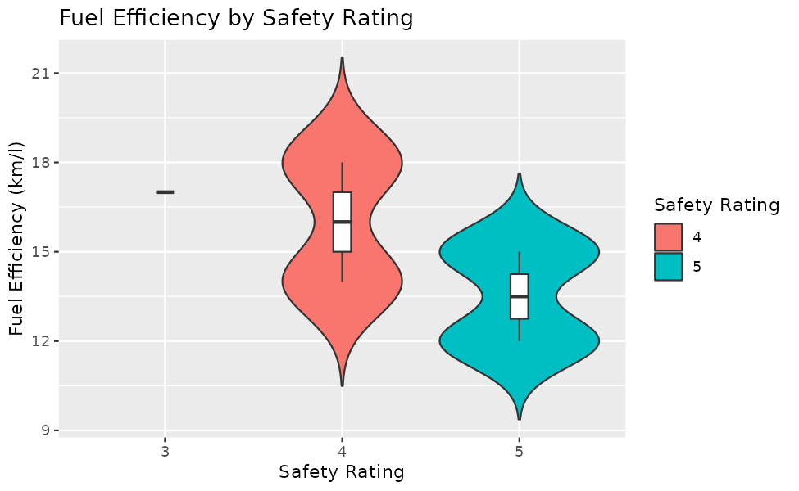
Result
The violin plot compares fuel efficiency for each safety rating. Vehicles with Safety Rating 4 have an average fuel efficiency of 16 km/l (range 14 to 18), vehicles with Safety Rating 5 have an average of 13.5 km/l (range 12 to 15), and the only vehicle with Safety Rating 3 has 17 km/l.
Safety Rating 4 shows a wider spread (standard deviation 2.83) than Safety Rating 5 (standard deviation 2.12). The central tendency decreases as the safety rating increases, which shows that the more highly rated vehicles in this dataset tend to be less fuel efficient. Since Safety Rating 3 has only one observation, its violin cannot be drawn and it appears as a single line.

Question 2: Construct a Scatter Plot Between Horsepower and Top Speed
R Code
ggplot(vehicle, aes(x = Horsepower, y = Top_Speed, color = Engine_Size)) +
geom_point(size = 4) +
labs(
title = "Horsepower vs Top Speed",
x = "Horsepower",
y = "Top Speed (km/h)",
color = "Engine Size (L)"
)

cor(vehicle$Horsepower, vehicle$Top_Speed)
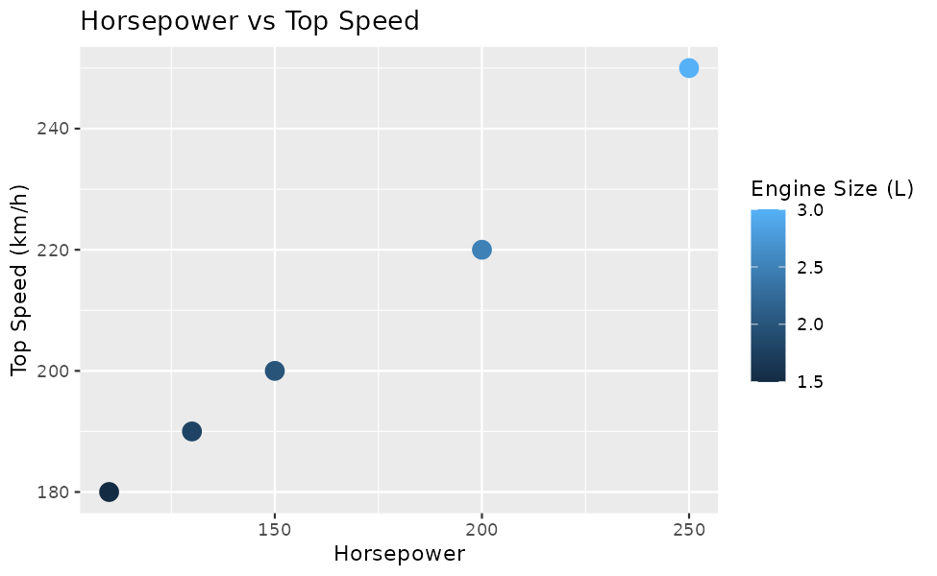
Result
The correlation between Horsepower and Top_Speed is 0.997, which is a very strong positive correlation. As horsepower increases, the top speed increases almost in a straight line.
The colour scale shows that vehicles with larger engines (V3 with 3.0 L and V4 with 2.5 L) lie at the upper right of the plot with high horsepower and high top speed, while the smaller engines (V1 with 1.5 L and V5 with 1.8 L) lie at the lower left. This shows that engine size, horsepower, and top speed increase together.

Question 3: Create a Correlation Heatmap for All Numerical Variables
R Code
library(reshape2)

num <- vehicle[, c("Engine_Size", "Horsepower", "Fuel_Efficiency",
"Top_Speed", "Safety_Rating")]
cor_matrix <- round(cor(num), 2)
cor_data <- melt(cor_matrix)

ggplot(cor_data, aes(x = Var1, y = Var2, fill = value)) +
geom_tile(color = "white") +
geom_text(aes(label = value)) +
scale_fill_gradient2(low = "blue", mid = "white", high = "red",
limits = c(-1, 1)) +
labs(title = "Correlation Heatmap of Vehicle Variables",
x = "", y = "", fill = "Correlation") +
theme(axis.text.x = element_text(angle = 30, hjust = 1))
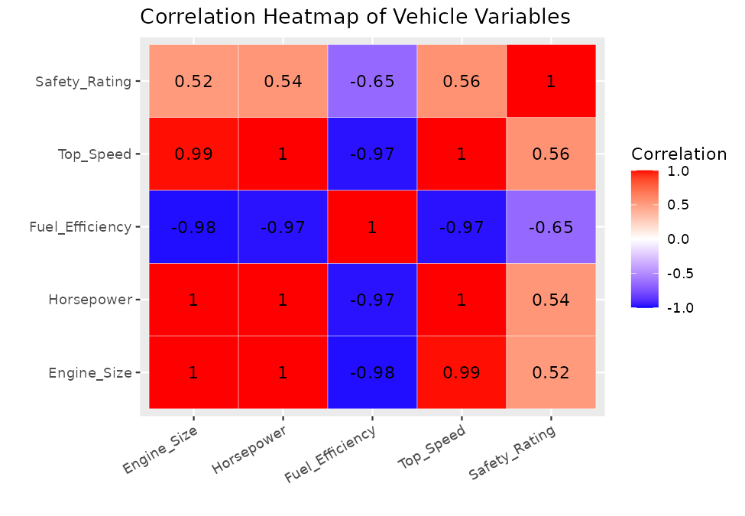
Result
The heatmap shows that Top_Speed is most strongly associated with Horsepower (1.00) and Engine_Size (0.99), both strong positive correlations. Fuel_Efficiency has a strong negative correlation with Top_Speed (-0.97), and Safety_Rating has a moderate positive correlation with Top_Speed (0.56).
Therefore, engine power is the main factor that influences vehicle performance, and higher performance comes at the cost of lower fuel efficiency.

Question 4: Design an Interactive Dashboard in Tableau
Procedure (Tableau)
Step 1: Save the vehicle dataset as a CSV or Excel file and connect it to Tableau using Connect > Text file or Microsoft Excel.
Step 2: Create the bar chart sheet: drag Vehicle_ID to Columns and Fuel_Efficiency to Rows. Drag Safety_Rating to Color.
Step 3: Create the scatter plot sheet: drag Horsepower to Columns and Top_Speed to Rows. Drag Vehicle_ID to Label and Engine_Size to Color. Change the aggregation of both measures to Dimension or disable Aggregate Measures from the Analysis menu so that each vehicle appears as a point.
Step 4: Drag Engine_Size and Safety_Rating to the Filters shelf, right-click each filter, and select Show Filter. Choose Apply to Worksheets > All Using This Data Source so that both filters control both sheets.
Step 5: Create a new dashboard, drag both sheets onto it, and place the Engine_Size and Safety_Rating filters on the side. Give the dashboard a title.
(Insert the Tableau dashboard screenshot here)
Result
The interactive dashboard displays the fuel efficiency of each vehicle and the relationship between horsepower and top speed, with filters for Engine_Size and Safety_Rating.
Analytical interpretation: V1 and V5 are the most fuel efficient (18 and 17 km/l) but have the lowest top speeds (180 and 190 km/h). V3 has the highest top speed (250 km/h) but the lowest fuel efficiency (12 km/l). V2 (2.0 L, 15 km/l, 200 km/h, Safety Rating 5) gives the best balance of fuel efficiency, performance, and safety, followed by V4.

